Lab 2: Containerization & Kubernetes Orchestration
Task - 3. Docker Storage
Demonstrate:
- Loss of container-layer data after container deletion.

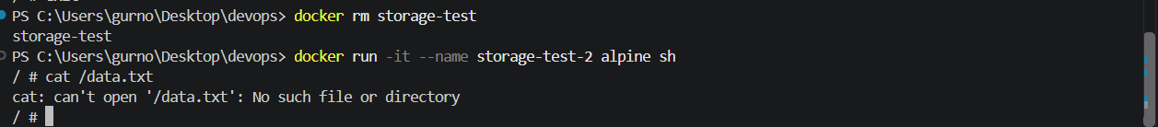
That proves that data stored only in the container layer is lost when the container is deleted.
- Permanent storage using a Docker named volume and bind mount
